18. Demonstrate Storage as a Service (SaaS) create and configure a new VM
Image in any Public Cloud Service Provider.
Aim: To Demonstrate Storage as a Service (SaaS) create and configure a new VM
Image in any Public Cloud Service Provider.
PROCEDURE:
STEP 1: Open The Microsoft Azure
STEP 2: Go to Resources and Click Add resouces
STEP 3: searh for virtual Saas and open it and name it
STEP 4: After that Set the username and password for it
STEP 5: After Creating all you will go main page
STEP 6: Make further changes to the Azure
STEP 7: Then Set the Image and run it
STEP 7:Then you will get Your Deployment is Complete

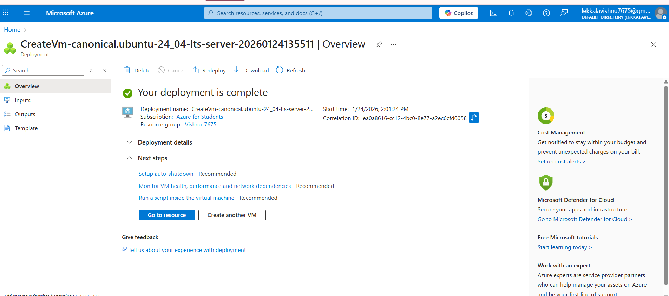

After That generate the image


